AP Computer Science
Final Project - “Indexing and the Word-Location Trick”
Indexing Algorithms

Search engines can sift through tens of billions of web pages and index those pages so that humans can quickly and accurately find pertinent information with the click of a button. How do search engines such as Google perform this magic you ask?

In this program, we will write methods that perform a simple, yet effective form of this powerful indexing algorithm*. In the project template that was sent to you, the WebPageProcessor class has a method “fileToLetters()” that reads plain text from a text file (representing a random web page on the net) and places each letter into an ArrayList, one letter per element. For example, if the text in a file “page1.txt” is:

“The cat in the hat”

then fileToLetters(“page1.txt”) will store each letter (a String of length 1) as one element in an ArrayList of Strings as shown below:
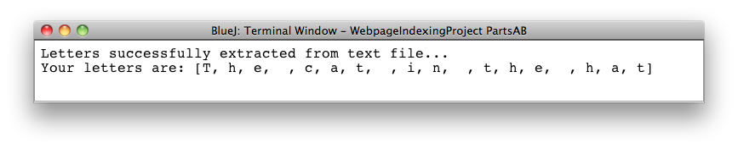
Actual HTML formatted web pages are much more complex than a raw text file, but this simple example will give you the basic idea behind the logic of the indexing algorithm.

Part A – fileToLetters()
a. Create a plain text file using Word or other word processor and save it as a plain text file called “myfile.txt” file in the WebpageIndexingProject project folder sent to you. In this simple example, only include one line of text with no “enter”s or “return”s that would create a second line of text (we could, of course, process “enter” keystrokes and other non-standard characters; we will save that for another day).
b. Edit the “WebpageProcessorDriver” so that the argument to the method fileToLetters() is “myfile.txt”.
c. Run the “WebpageProcessorDriver” to verify that your file “myfile.txt” is converted to an ArrayList of Strings by the program.

* an additional algorithm, the “Ranking Algorithm”, is used by Google to rank pages according to their relevance. This algorithm is what separated Google from the rest of the pack.
Part B – Class WebpageProcessor
Given the method fileToLetters(“somefile.txt”), you will write the WebpageProcessor method lettersToPage() that will take as its parameter an ArrayList of letters (i.e. Strings of length 1 as shown in the example above) and convert it into a ProcessedPage which consists of an ArrayList of words as shown below.

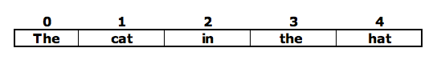

Since this ArrayList of words represents the words on a webpage, this method will return a ProcessedPage object that “has-an” ArrayList of these words. As shown above, the result is a ProcessedPage object that contains an ArrayList<String> of length 5 that has one word per element.

Examine the ProcessedPage class in the WebpageIndexingProject template that was sent to you for complete details of this class.

Write the WebpageProcessor method lettersToPage() that has the method header as shown below:

public ProcessedPage lettersToPage(ArrayList<String> letters)

